|  |
| --- |
| Octathorn |
| Movable Pool Platform |
|  |
|  |
|  |
| **11/15/2022** |

|  |
| --- |
| List of components used and methodology used to send data to a server |

**List of components in Hardware:**

* Esp32 WROOM-32

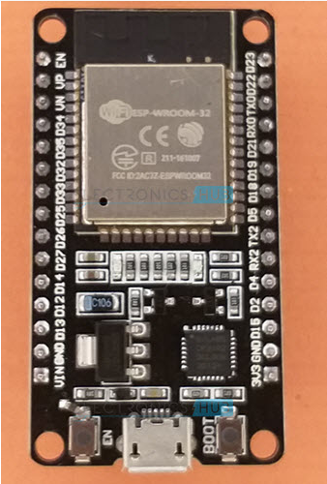

* Switch for wifi configuration

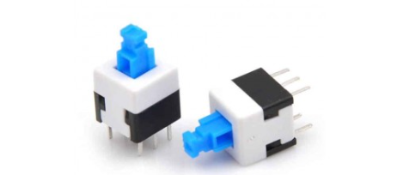

* 3 push buttons for inputs

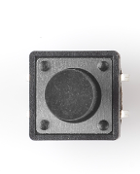

* 2 potentiometers to mimic transducer and pressure sensors

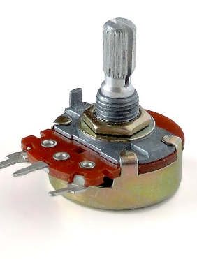

* 1 RTC module to keep the current time

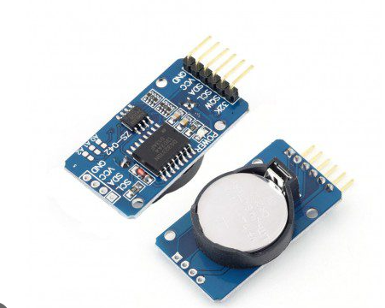

**List of software used:**

* Arduino ide to develop the software
* Postman to use for a mock server for current milestone

**Methodology of software:**

The controller used to send data from sensors to a mock server used is an esp32. 2 potentiometers are used to mimic the sensors they send voltages to the controller which is then read by the controller using its analog pins and is converted to the corresponding pressure values and heights respectively by the algorithm. 3 buttons are used for power, up and down buttons for the platform and an RTC module is used to keep track of current time and a time stamp is saved whenever a button is pressed and is than sent to the mock server. All of the data is compiled and sent every 5 seconds to the mock server created on postman software (for demonstration purposes only) using http post requests. A Wi-Fi switch is used to configure the Wi-Fi from webpage, when the Wi-Fi credentials are entered on the webpage they are stored by the microcontroller inside its memory so that if it is turned off it will remember the Wi-Fi credentials and connect to it automatically.